# Exercise: ReactJS Events and Forms

This is an exercise for the ["ReactJS Fundamentals Course"](https://softuni.bg/opencourses/reactjs-fundamentals) at [SoftUni.](https://softuni.bg)

## Task Requirements

Create simple react application that has the following functionalities:

* Can **registe**r a user
* Can **login** a user
* Can **create** a game
* Can **view all** the **games** in the database

## Server

You are provided with a server that will help us fetch the data from our database. Explore the code of the server. After that run **npm install** and then **start the server**

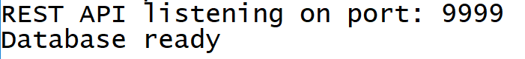

## Database

The database has 2 tables: **games** and **users**.

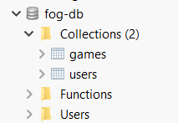

* The **game model** has a **title, description** and **imageUrl**
* The **user model** has an **email** and an **username**

## Skeleton

About **70%** of the application will be provided to you. **Explore** the provided skeleton and **implement** the logic in all the **TODO** sections. Since in the app we use a **React UI Framework** called [material ui](https://material-ui.com/), you may want to check it out to feel more comfortable.

## TODO sections

### App.js

Here there are some **functions you have to implement**. Explore the code of the **register**, **login, createGame** forms to get more familiar with what those functions should do. Most of **those functions** **will be passed to the child components** of the app, so you **might be returning** to this file later for **reference**

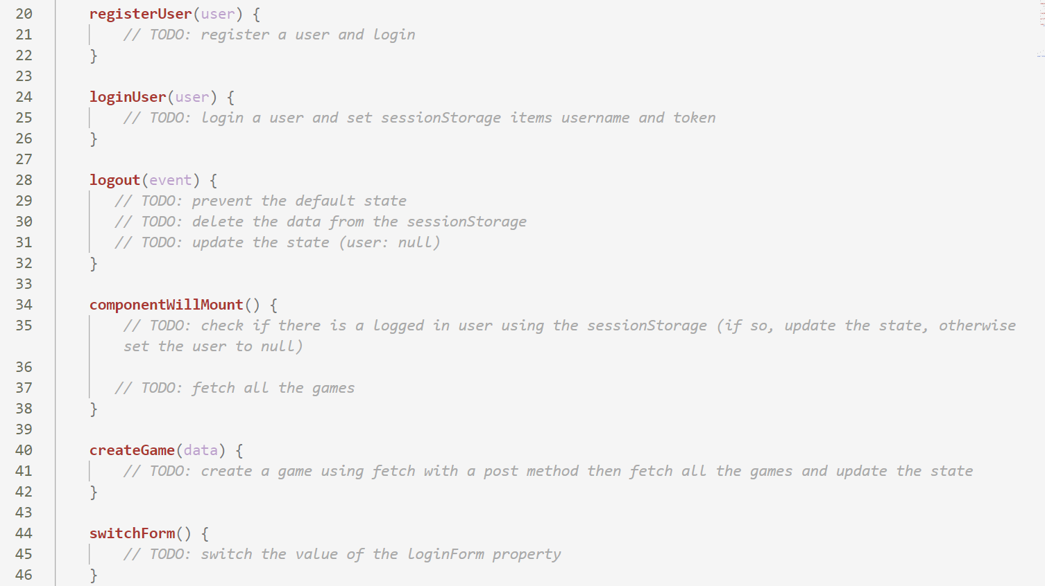

* Use the **fetch** function when needed to fetch data from the server.

### DynamicForm.js

Explore the **App.js** file. There you should see the following:

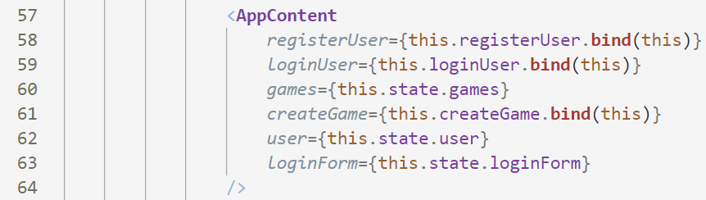

Here you see that the **AppContent** component is rendered and some properties are passed

Explore the **AppContent.js** file:

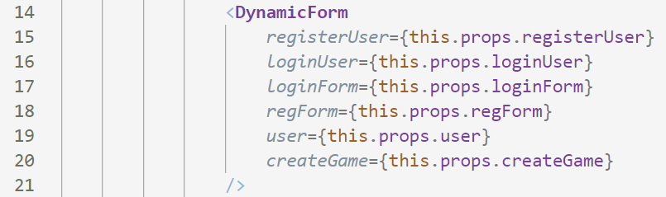

Here we see that the **DynamicForm** is being rendered. The same properties are being passed

From here we have to go to **DynamicForm.js** file:



* Depending on whether there is a **loggedIn** user and whether **loginForm** is **true/false**, **render** the different forms

### LoginForm.js

After you have done that, go to **LoginForm.js**. There you see the following **TODO**:

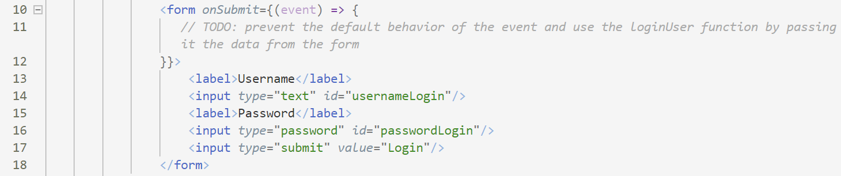

* Use the **loginUser function** you wrote in the **App.js** to **log-in a user** using the data from the form

### RegisterForm.js

Now it is time for the **RegisterForm.js** file:

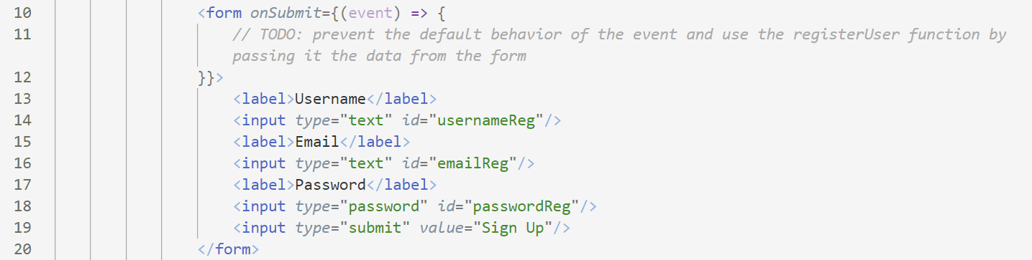

* Use the **registerUser** **function** you wrote in the **App.js** to register a new user

### CreateForm.js

And finally, the **CreateForm.js** file:



* Here you have to use the **createGame function** you wrote in the **App.js** and pass it all the data from the form

## Views

Here is the **default page** when the user is not registered or logged:



When you click on the **login button**, you should see this:

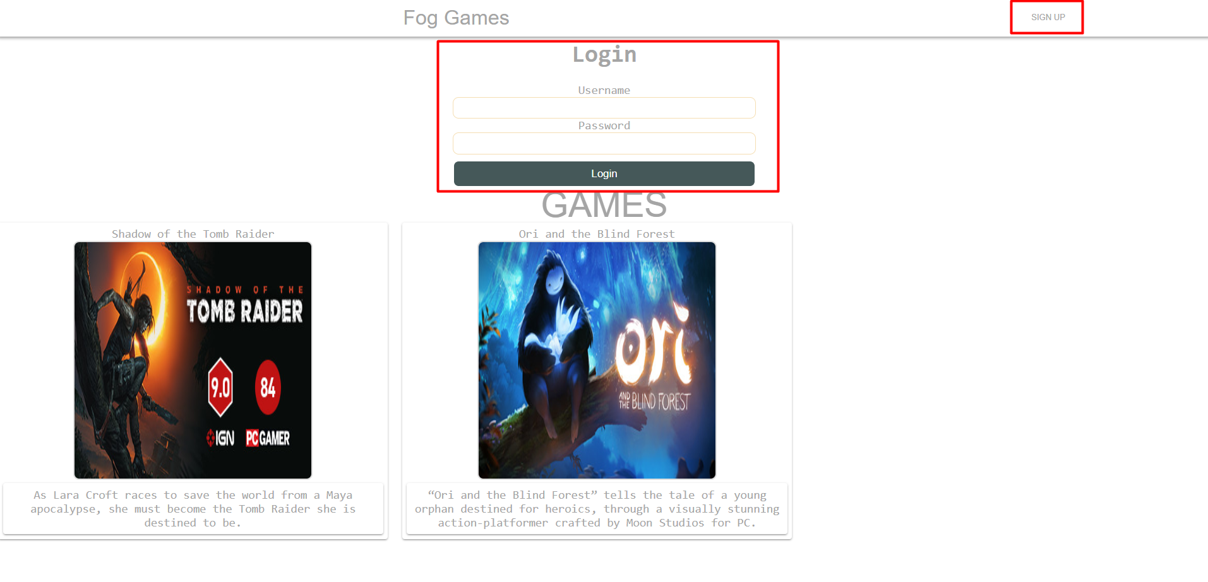

After **login/register**, you should see the following:

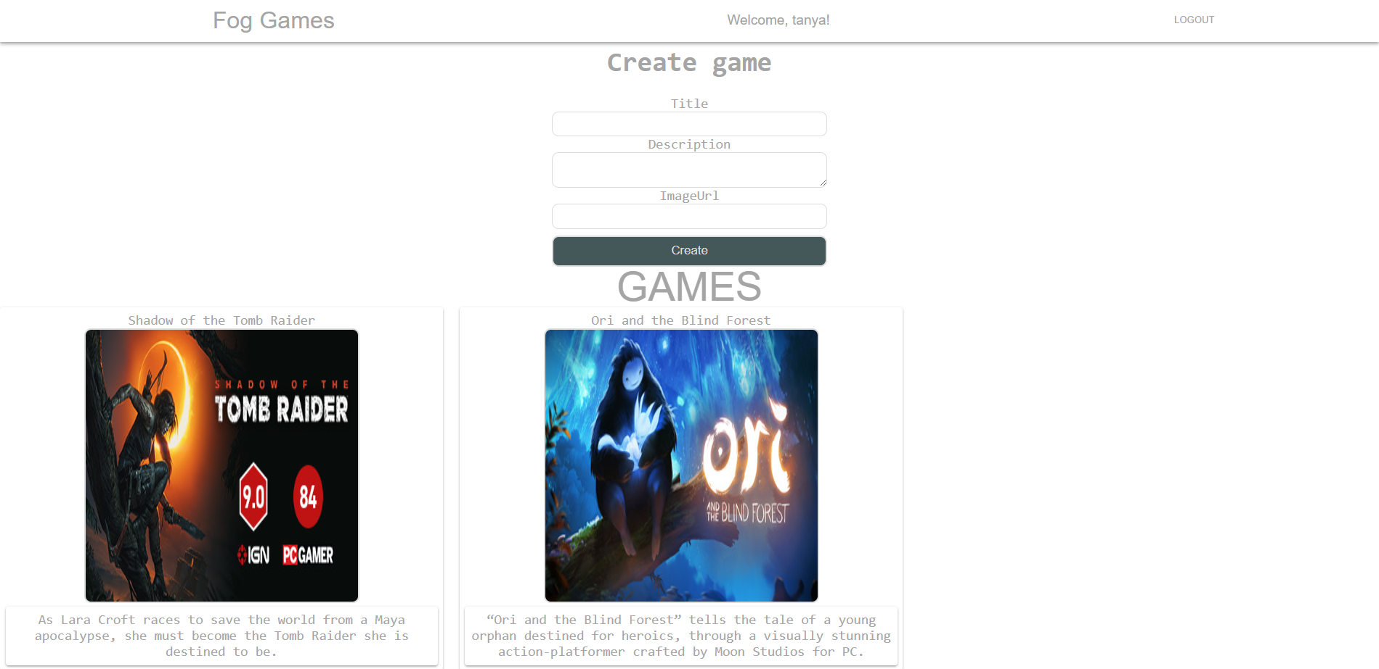

After **logout**, display the **default view**

When a **game is created**, **re-render** the **current view**